# **P06-02 Jenny's Hair Salon Relational**

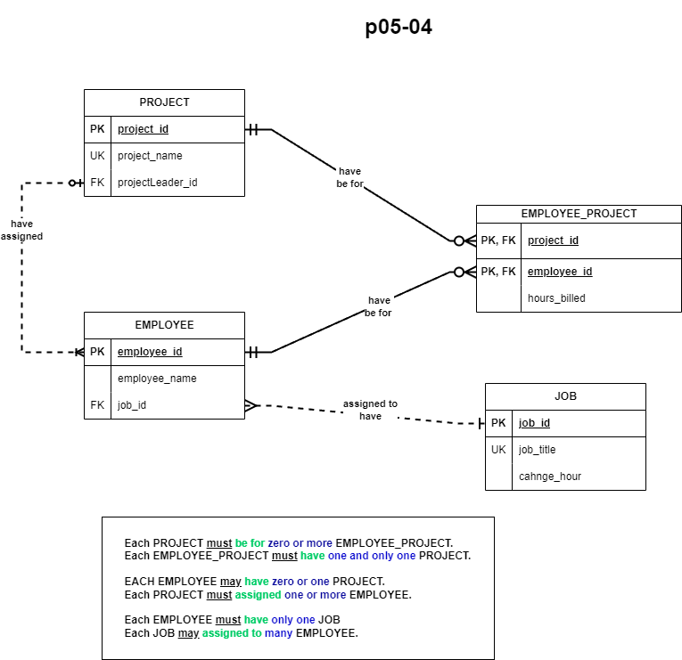

# **Relational Database table of P0604**

|  |  |  |  |  |  |
| --- | --- | --- | --- | --- | --- |
| PROJECT | | | | |  |
| Description | Key Type | Optionality | Column Name | Data Type | Length |
| Project ID Number | PK | * | project_id | INTEGER |  |
| Project Name | UK | * | project_name | VARCHAR | 255 |
| Project Leader ID | FK | * | projectLeader_id | INTEGER |  |
|  | | | | | |
| EMPLOYEE | | | | | |
| Description | Key Type | Optionality | Column Name | Data Type | Length |
| Employee ID | PK | * | employee_id | INTEGER |  |
| Employee Name |  | 0 | employee_name | VARCHER | 32 |
| Job ID | FK | * | job_id | INTEGER |  |
|  | | | | | |
| EMPLOYEE_PROJECT | | | | | |
| Description | Key Type | Optionality | Column Name | Data Type | Length |
| Project ID | PK, FK | * | project_id | INTEGER |  |
| Employee ID | PK, FK | * | employee_id | INTEGER |  |
| Employee Hours Billed |  | 0 | hours_billed | DECIMAL | 4,2 |
|  | | | | | |
| JOB | | | | | |
| Description | Key Type | Optionality | Column Name | Data Type | Length |
| Job ID | PK | * | job_id | INTEGER |  |
| Job Title | UK | 0 | job_title | VARCHAR | 255 |
| Job Change Hour |  | 0 | Change_hour | TIME |  |

Foreign Key Relationship Mapping

**1: PROJECT**

FK: projectLeader_id >> EMPLOYEE

**2: EMPLOYEE**

FK: job_id >> JOB

**3: EMPLYOEE_PROJECT**

FK: project_id >> PROJECT

FK: employee_id >> EMPLOYEE